ROHM Switching Regulator Solutions

Evaluation Board:

Synchronous Buck Converter

Integrated FET

BD9D321EFJ-E2EVK-101(1.8V | 3A Output)

No.000000000

* Introduction

This application note will provide the steps necessary to operate and evaluate ROHM’s synchronous buck DC/DC converter using the BD9D321EFJ evaluation boards. Component selection, board layout recommendations, operation procedures and application data is provided.

* Description

This evaluation board has been developed for ROHM’s synchronous buck DC/DC converter customers evaluating BD9D321EFJ. While accepting a power supply of 4.5-18.0V, an output of 1.8V can be produced. The IC has internal 100mΩ high-side P-channel MOSFET and 70mΩ low-side N-channel MOSFET and a synchronization frequency 700 kHz. A fixed Soft Start circuit prevents inrush current during startup along with UVLO (low voltage error prevention circuit) and TSD (thermal shutdown detection) protection circuits. An EN pin allows for simple ON/OFF control of the IC to reduce standby current consumption.

* Applications

Step-down Power Supply for DSPs, FPGAs,

Microprocessors, etc.

Set-top Box

LCD TVs

DVD / Blu-ray Player / Recorder

Entertainment Devices

* Evaluation Board Operating Limits and Absolute Maximum Ratings

|  |  |  |  |  |  |  |  |
| --- | --- | --- | --- | --- | --- | --- | --- |
| **Parameter** | | **Symbol** | **Limit** | | | **Unit** | **Conditions** |
| **MIN** | **TYP** | **MAX** |
| **Supply Voltage** | | | | | | | |
|  | BD9D321EFJ | VCC | 4.5 | - | 18.0 | V |  |
| **Output Voltage / Current** | | | | | | | |
|  | BD9D321EFJ | VOUT | - | 1.8 | - | V |  |
| IOUT | - | - | 3 | A |  |

* Evaluation Board

Below is evaluation board with the BD9D321EFJ.

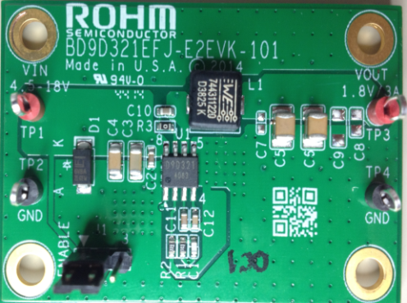

Fig 1: BD9D321EFJ Evaluation Board

* Evaluation Board Schematic

**Vout**

**GND**

**EN**

BD9673EFJ Eval Board

Below is evaluation board schematic for BD9D321EFJ.

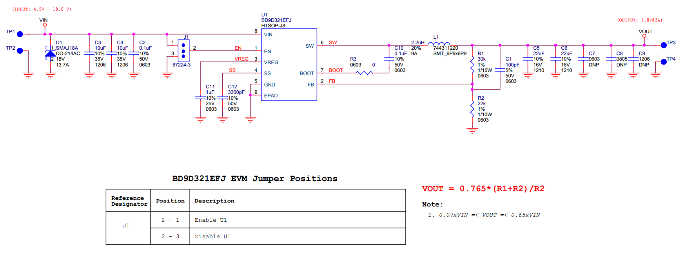

Fig 2: BD9D321EFJ Evaluation Board Schematic

* Evaluation Board I/O

Below is reference application circuit that shows the inputs (VIN and EN) and the output (VOUT).

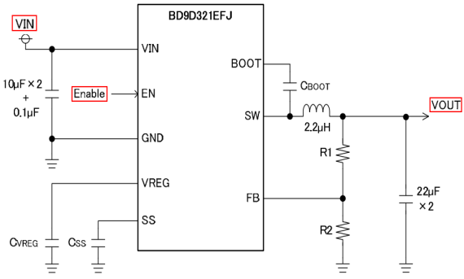

Fig 3: BD9D321EFJ Evaluation Board I/O

* Evaluation Board Operation Procedures

Below is the procedure to operate the evaluation board.

1. Connect power supply’s GND terminal to GND test point TP2 on the evaluation board.
2. Connect power supply’s VCC terminal to VIN test point TP1 on the evaluation board. This will provide VIN to the IC U1. Please note that the VCC should be in range of 4.5V to 18V.
3. Check if shunt jumper of J1 is at position ON (Pin2 connect to Pin1, EN pin of IC U1 is pulled high).
4. Connect electronic load to TP3 and TP4. Do not turn on load (electronic load is off power).
5. Turn on power supply. The output voltage VOUT(+1.8V) can be measured at the test point TP3. Now turn on the load. The load can be increased up to 3A MAX.

*Notes*:

*Do not perform hot plugging on this board, the inrush current is so high (IIN_MAX >=65A) which exceed the clamping range of SMAJ series (IPP=20A@VC=20V). The SMAJ diode can not suppress the voltage glitch over the maximum voltage input rating 20V of BD9D321EFJ, so IC is not protected when doing hot plug test. Please refer figure 4.*

* Reference Application Data for BD9D321EFJ-E2EVK-101

Following graphs show hot plugging test, quiescent current, efficiency, load response, output voltage ripple response of the BD9D321EFJ evaluation board.

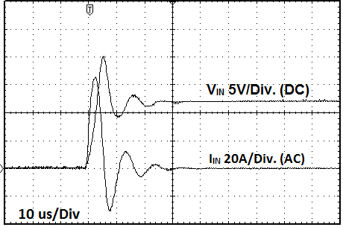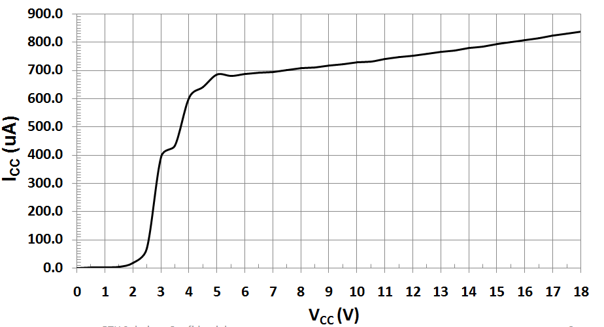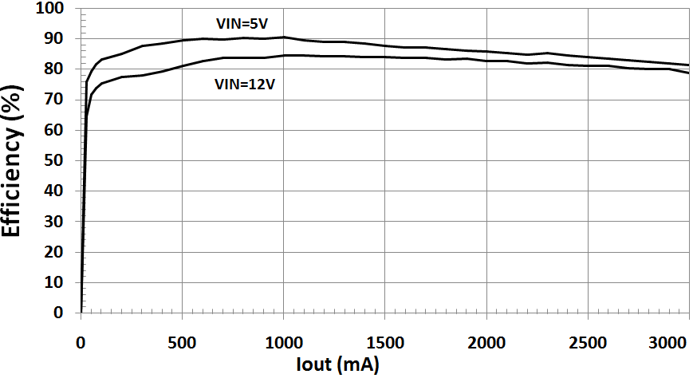

**Fig 4: Hot Plug-in Test with Zener Diode SMAJ18A, VIN=12V, VOUT=1.8V, IOUT=3A,**

**Fig 5: Circuit Current vs. Power supply Voltage Characteristics (Temp=25oC)**

**Fig 6: Electric Power Conversion Rate**

**(VOUT=1.8V)**

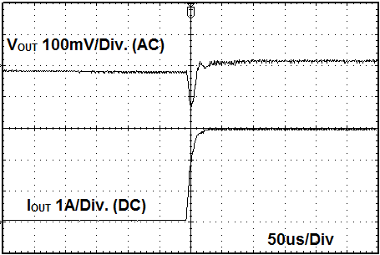 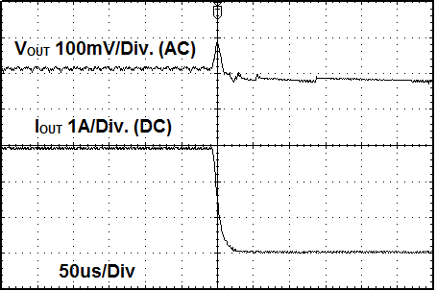

Fig 7: Load Response Characteristics

(VIN=5V, VOUT=1.8V, IOUT=0🡪3A)

Fig 8: Load Response Characteristics

(VIN=5V, VOUT=1.8V, IOUT=3A🡪0A)

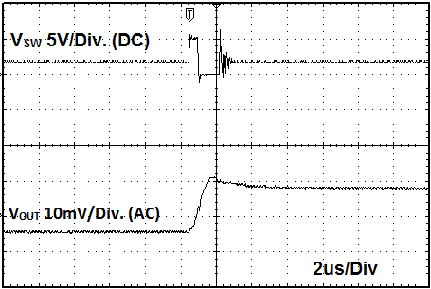 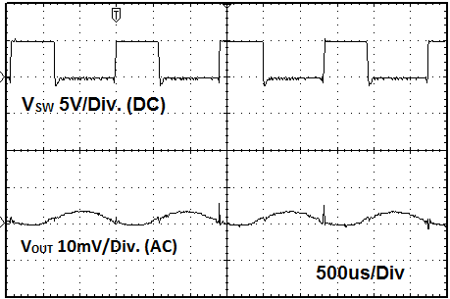

Fig 9: Output Voltage Ripple Response Characteristics

(VIN=5V, VOUT=1.8V, IOUT=0A)

Fig 10: Output Voltage Ripple Response Characteristics

(VIN=5V, VOUT=1.8V, IOUT=3A)

* Evaluation Board Layout Guidelines

In the step-down DC/DC converter, a large pulse current flows into two loops. The first loop is the one into which the current

flows when the high side FET is turned ON. The flow starts from the input capacitor CIN, runs through the FET, inductor L

and output capacitor COUT and back to ground of CIN via ground of COUT. The second loop is the one into which the current

flows when the low side FET is turned on. The flow starts from the low side FET, runs through the inductor L and output

capacitor COUT and back to ground of the low side FET via ground of COUT. Route these two loops as thick and as short as

possible to allow noise to be reduced for improved efficiency. It is recommended to connect the input and output capacitors

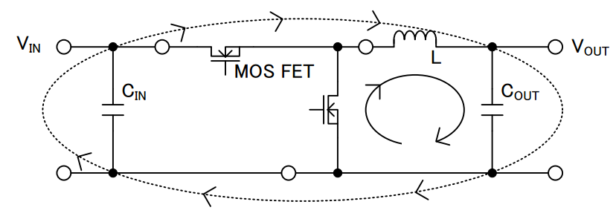

Fig 11: Current Loop of Buck Converter

directly to the ground plane. The PCB layout has a great influence on the DC/DC converter in terms of all of the heat

generation, noise and efficiency characteristics.

Accordingly, design the PCB layout considering the following points.

* Connect an input capacitor as close as possible to the IC VIN terminal on the same plane as the IC.
* If there is any unused area on the PCB, provide a copper foil plane for the ground node to assist heat dissipation from

the IC and the surrounding components.

* Switching nodes such as SW are susceptible to noise due to AC coupling with other nodes. Route the coil pattern as

thick and as short as possible.

* Provide lines connected to FB and SS far from the SW nodes.
* Place the output capacitor away from the input capacitor in order to avoid the effect of harmonic noise from the input.

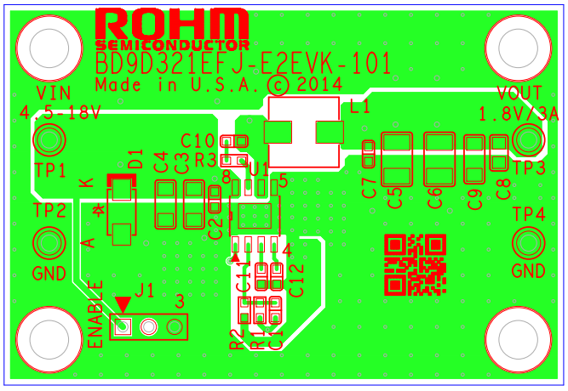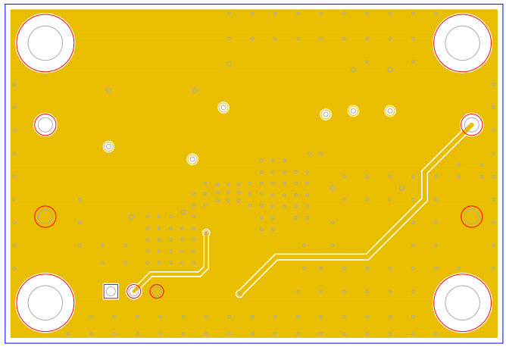

Fig 12: BD9D321EFJ-E2EVK-101 Board PCB layout

TOP layer

BOTTOM layer

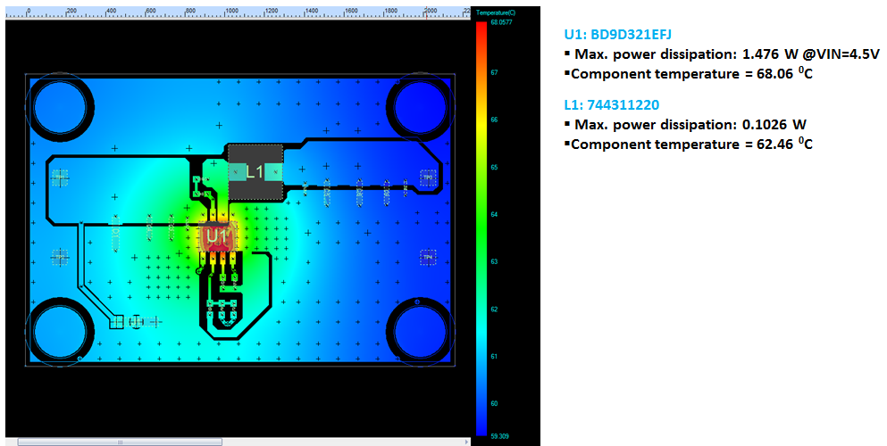

Fig 13: BD9D321EFJ-E2EVK-101 Thermal Characteristics at Temp=25oC,

no air flow, VIN=4.5V, VOUT=1.8V, IOUT=3A

Thermal note: If the board is operated above room temperature (T>25oC), an active cooling source (fan) or heat sink (soldered to bottom of PCB) need to be added.

Additional layout notes:

* The thermal Pad on the back side of IC has the great thermal conduction to the chip. So using the GND plane as broad and wide as possible can help thermal dissipation. And a lot of thermal via for helping the spread of heat to the different layer is also effective.
* The input capacitors should be connected to GND as close as possible to the VIN terminal.
* The inductor and the output capacitors should be placed close to SW pin as much as possible.
* For applications operating at or near maximum voltage conditions (18V max), additional precautions regarding heat dissipation need to be considered during board layout. The provided evaluation board is a 4-layer board meant for evaluation purposes only. At maximum conditions, the IC’s internal thermal shutdown detection circuit will be potentially initiated and the output disabled until the junction temperature falls. For final designs operating near these conditions, we recommend using one of the below PCB options for better heat dissipation of the IC.

1. Use of a 4-layer PCB with internal GND planes connected to the IC GND pins.
2. Use of a 2-layer PCB with a heat sink attached to the IC package.
3. Use of a 2-layer PCB with a copper plane (>1oz) attached to the IC.

* Calculation of Application Circuit Components

(1) Output LC Filter Constant

The DC/DC converter requires an LC filter for smoothing the output voltage in order to supply a continuous current to the

load. Selecting an inductor with a large inductance causes the ripple current ∆ILthat flows into the inductor to be small.

However, decreasing the ripple voltage generated in the output is not advantageous in terms of the load transient

response characteristic. An inductor with a small inductance improves the transient response characteristic but causes the

inductor ripple current to be large which increases the ripple voltage in the output voltage, showing a trade-off relationship.

The recommended inductor values are shown in Fig 14.

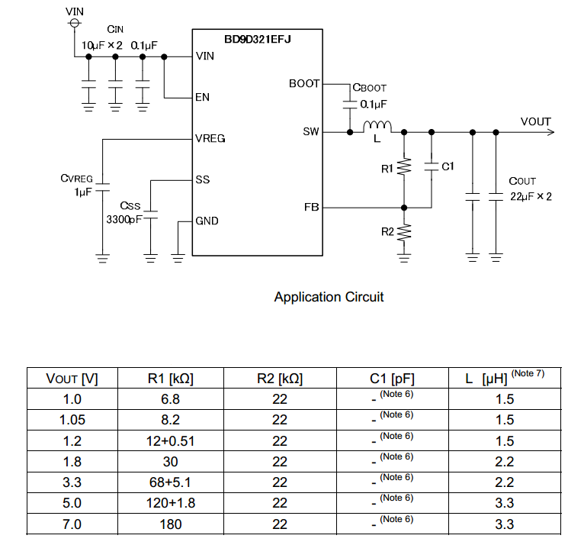

Fig 14: Recommended Component values

(Note 6) C1 is a feed forward capacitor. The IC can operate normally even if the capacitor is not connected.

Additional phase boost can be achieved by adding the 5pF to 100pF capacitor (C1) in parallel with R1.

(Note 7) Recommended Inductor

・ALPS GLMC series

・TDK SPM6530 series

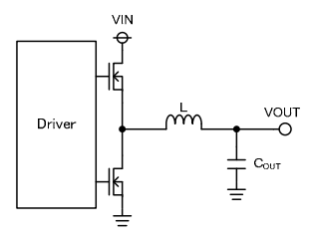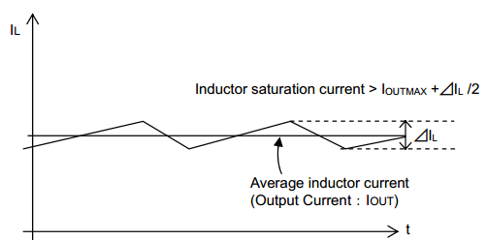

Fig 16: Output LC filter circuit

Fig 15: Waveform of current through inductor

The inductor peak to peak ripple current ∆IL is calculated using the following equation.

For example, with VIN= 12 V, VOUT= 1.8 V, L = 2.2µH and the switching frequency FOSC = 700 kHz, the calculated peak

current ∆IL is 1.0A.

Then, the inductor saturation current must be larger than the sum of the maximum output current (IOUT MAX) and 1/2 of the

inductor ripple current (∆IL / 2).

The output capacitor **COUT** affects the output ripple voltage characteristics. The output capacitor COUT must satisfy the

required ripple voltage characteristics.

The output ripple voltage can be represented by the following equation.

RESR is the Equivalent Series Resistance (ESR) of the output capacitor.

* The capacitor rating must allow a sufficient margin with respect to the output voltage.

The output ripple voltage can be decreased with a smaller ESR.

A ceramic capacitor of about 22 µF to 100 µF is recommended.

* Pay attention to total capacitance value, when additional capacitor CLOAD is connected in addition to output capacitor

COUT. Then, please determine CLOAD and soft start time Tss (Refer to **(3) Soft Start Setting**) as satisfying the following

equation.

IOCP is Over Current Protection Current limit value

(**2) Output Voltage Setting**

The output voltage value can be set by the feedback resistance ratio.

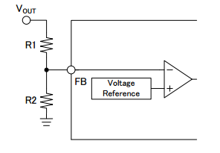

BD9D321EFJ can operate under the condition which satisfies

the following equation.

Fig 17: Feedback Resistor Circuit

**(3) Soft Start Setting**

Turning the EN terminal signal High activates the soft start function. This causes the output voltage to rise gradually while

the current at startup is placed under control. This allows the prevention of output voltage overshoot and inrush current.

The rise time depends on the value of the capacitor connected to the SS terminal.

Td : Soft Start Delay Time

TSS : Soft Start Time

CSS : Capacitor connected to Soft Start Time Terminal

VFB : FB Terminal Voltage (0.765V Typ)

VTH : Internal MOS threshold voltage (0.7V Typ)

ISS : Soft Start Terminal Source Current (2.0µA Typ)

With CSS = 3300 pF,

Td = ( 3300 pF x 0.7 V ) / 2.0 µA = 1.16 msec

TSS = ( 3300 pF x 0.765 V x 1.15 ) / 2.0 µA = 1.45 msec

* **Evaluation Board BOM**

Below is a table with the build of materials. Part numbers and supplier references are provided.

|  |  |  |  |  |  |
| --- | --- | --- | --- | --- | --- |
| **Item** | **Qty.** | **Ref** | **Description** | **Manufacturer** | **Part Number** |
| 1 | 1 | C1 | CAP CER 100PF 50V 5% NP0 0603 | Murata | GRM1885C1H101JA01D |
| 2 | 2 | C2,C10 | CAP CER 0.1UF 50V 10% X7R 0603 | Murata | GRM188R71H104KA93D |
| 3 | 2 | C3,C4 | CAP CER 10UF 35V 10% X5R 1206 | Murata | GRM31CR6YA106KA12L |
| 4 | 2 | C5,C6 | CAP CER 22UF 25V 10% X5R 1210 | Murata | GRM32ER61E226KE15L |
| 5 | 1 | C11 | CAP CER 1UF 25V 10% X7R 0603 | Murata | GRM188R71E105KA12D |
| 6 | 1 | C12 | CAP CER 3300PF 50V 10% X7R 0603 | Murata | GRM188R71H332KA01D |
| 7 | 1 | D1 | TVS DIODE 18VWM 29.2VC SMA | Littelfuse Inc | SMAJ18A |
| 8 | 1 | J1 | CONN HEADER VERT .100 3POS 15AU | TE Connectivity | 87224-3 |
| 9 | 1 | L1 | INDUCTOR POWER 2.2UH 9A SMD | Wurth | 744311220 |
| 10 | 1 | R1 | RES 30K OHM 1/10W 1% 0603 SMD | Rohm | MCR03ERTF3002 |
| 11 | 1 | R2 | RES 22K OHM 1/10W 1% 0603 SMD | Rohm | MCR03ERTF2202 |
| 12 | 1 | R3 | RES 0.0 OHM 1/10W JUMP 0603 SMD | Rohm | MCR03ERTJ000 |
| 13 | 2 | TP1,TP3 | TEST POINT PC MULTI PURPOSE RED | Keystone Electronics | 5010 |
| 14 | 2 | TP2,TP4 | TEST POINT PC MULTI PURPOSE BLK | Keystone Electronics | 5011 |
| 15 | 1 | U1 | IC REG BUCK SYNC ADJ 3A 8HTSOP | Rohm | BD9D321EFJ-E2 |
| 16 | 1 |  | Shunt jumper for header J1(item #8) CONN SHUNT 2POS GOLD W/HANDLE | TE Connectivity | 881545-1 |

**Notes**

No copying or reproduction of this document, in part or in whole, is permitted without the consent of ROHM Co.,Ltd.

The content specified herein is subject to change for improvement without notice.

The content specified herein is for the purpose of introducing ROHM's products (hereinafter"Products"). If you wish to use any such Product, please be sure to refer to the specifications,which can be obtained from ROHM upon request.

Examples of application circuits, circuit constants and any other information contained hereinillustrate the standard usage and operations of the Products. The peripheral conditions mustbe taken into account when designing circuits for mass production.

Great care was taken in ensuring the accuracy of the information specified in this document.However, should you incur any damage arising from any inaccuracy or misprint of suchinformation, ROHM shall bear no responsibility for such damage.

The technical information specified herein is intended only to show the typical functions of andexamples of application circuits for the Products. ROHM does not grant you, explicitly orimplicitly, any license to use or exercise intellectual property or other rights held by ROHM andother parties. ROHM shall bear no responsibility whatsoever for any dispute arising from theuse of such technical information.

The Products specified in this document are intended to be used with general-use electronicequipment or devices (such as audio visual equipment, office-automation equipment, communicationdevices, electronic appliances and amusement devices).

The Products specified in this document are not designed to be radiation tolerant.

While ROHM always makes efforts to enhance the quality and reliability of its Products, aProduct may fail or malfunction for a variety of reasons.

Please be sure to implement in your equipment using the Products safety measures to guardagainst the possibility of physical injury, fire or any other damage caused in the event of thefailure of any Product, such as derating, redundancy, fire control and fail-safe designs. ROHMshall bear no responsibility whatsoever for your use of any Product outside of the prescribedscope or not in accordance with the instruction manual.

The Products are not designed or manufactured to be used with any equipment, device orsystem which requires an extremely high level of reliability the failure or malfunction of whichmay result in a direct threat to human life or create a risk of human injury (such as a medicalinstrument, transportation equipment, aerospace machinery, nuclear-reactor controller, fuel-controlleror other safety device). ROHM shall bear no responsibility in any way for use of anyof the Products for the above special purposes. If a Product is intended to be used for anysuch special purpose, please contact a ROHM sales representative before purchasing.

If you intend to export or ship overseas any Product or technology specified herein that maybe controlled under the Foreign Exchange and the Foreign Trade Law, you will be required toobtain a license or permit under the Law.



Thank you for your accessing to ROHM product information.

More detail product information and catalogs are available, please contact us.

**ROHM Customer Support System**

<http://www.rohm.com/contact/>